TRANSPORTATION AND CIRCULATION

Introduction
Transportation is the movement of people and goods and may involve circulation by passenger vehicle, truck or trailer, railcar, plane, boat, bus, subway, bicycle, or other means. The local transportation system should provide safe and efficient mobility for people traveling using all transportation modes and should offer connections to regional facilities. Residents, businesses, students, visitors, and emergency services rely on an available and quality transportation system. The maintenance and enhancement of the transportation system impact Town resources, community character, and quality of life of new and existing residents, and can attract and respond to new development.
This section discusses the current transportation network available in the Town including highway and roadway infrastructure, bridges, mass transit, biking, and pedestrian facilities. Effective transportation of people and goods allows for more productivity and is important to the functionality of a municipality. Planning for transportation allows a community to align long-term goals with other aspects of community planning such as land use, economic development, and housing.
Relevant circulation patterns include routes both within Town boundaries as well as larger routes that link Mashpee to the region and to the State. These circulation routes support connectivity of local goods and services to regional and Statewide markets and connect residents to regional job centers. The scale and location of the road network contributes to both existing and future development patterns within the community. This chapter of the plan ties in closely with the land use, economic development, and housing chapters and will reference data from each that helps to inform transportation goals.

Existing Conditions
The following factors will affect the Town’s transportation network and have continual impacts on the Town’s influx in traffic volumes and future development.

Demographics
 | 2000 | 2010 | 2020 | Net change  2000-2020 |  | Net change  2010-2020
 |  |  |  | Total | Yearly | Total | Yearly
Mashpee, Massachusetts | 12,946 | 14,006 | 15,060 | 16.3% | .8% | 7.5% | .8%
Barnstable County, Massachusetts | 222,230 | 215,888 | 228,996 | -2.9% | 0.2% | 6.1% | 0.6%
Massachusetts | 6,349,097 | 6,547,629 | 7,029,917 | 10.7% | 0.5% | 7.4% | 0.7%
Table 9-1 summarizes total population estimates based on data from the U.S. Census Bureau for the years 2000, 2010, and 2020 at the local, county, and state levels.
Table 9-1. Total Estimated Population
Source: U.S. Census Bureau, 2000, 2010, 2020
Mashpee’s population reached an estimated 15,060 persons in 2020, an increase of almost 7.5 percent since 2010 (14,006 estimated population). Over the past ten years, the population increase experienced by Mashpee was in line with the population increase statewide (7.4 percent), but higher than the population increase in Barnstable County (around 6.1 percent). Between 2000 and 2020, Mashpee experienced a population increase of around 16 percent, while Barnstable County saw a decrease in population of around three percent.

Journey-to-Work Data
Figure 9-1 shows the most popular work destinations for Mashpee residents based on the most recent data from the U.S. Census American Community Survey 2011-2015 Five-Year Estimate. As shown in the figure, 1,820 Mashpee residents (approximately 34 percent of workers) work in Mashpee. A total of 1,344 residents (25 percent of workers) are employed in the Town of Barnstable. Mashpee residents also work within nearby communities such as Falmouth (830) and Sandwich (586).

Figure 9-1. Most Popular Work Destinations for Mashpee Residents
Source: U.S. Census Bureau, 2015
Figure 9-2 shows the major residence locations for people working in Mashpee based on the most recent data from the U.S. Census American Community Survey 2011-2015 Five-Year Estimate. Approximately 1,820 people who work in Mashpee also live in Mashpee (29 percent). A total of 986 Barnstable residents (16 percent) work in Mashpee. People who work in Mashpee also come from nearby towns including Falmouth, Sandwich, and Bourne. In total, more Mashpee residents are commuting out of Mashpee, than non-residents commuting into Mashpee.

Figure 9-2. Residence Location of Mashpee Workers

Source: U.S. Census Bureau, 2015

Vehicles Available
Figure 9-3 shows the number of vehicles available per household for both Mashpee and the State of Massachusetts based on the U.S. Census American Community Survey 2015-2019 Five-Year Estimate. As shown, 40 percent of households in Mashpee have access to one vehicle. The percentage of households in Mashpee with access to two or more vehicles is 57 percent, which is slightly greater than the percentage of households in the State with two or more vehicles (52 percent), and slightly lower than the percentage of households in Barnstable County with two or more vehicles available (60 percent). Approximately three percent of Mashpee households do not have access to a vehicle. This is less than the state average of over twelve percent, however, geographically the percent of households in Mashpee with access to no vehicle or one vehicle vary greatly. In the census tract in the northeast of Town framed by Route 151 to the south and Meetinghouse Road to the east, an estimated 57 percent of households have no vehicle or one vehicle, with an estimated 8 percent of households with no vehicle. The other three census tracts in Town have between 33 percent and 43 percent of households with one vehicle or no vehicle.

Figure 9-3. Vehicles Available Per Household
Source: U.S. Census Bureau, 2019

Mode Share and Commute Time
Figures 9-4 and 9-5 show the modes of transportation to work for Mashpee residents in 2019, the most recent year for which data is available. As shown, 83 percent of residents drove alone, eight percent carpooled, and five percent worked from home. Just one percent walked, and one percent took a taxi, motorcycle, bicycle, or other means, and one percent used public transportation. The percentage (83 percent) of Mashpee residents commuting to work by driving alone was slightly higher than the Barnstable County average of 80 percent and significantly higher than the Massachusetts average (70 percent). In both Barnstable County and Mashpee, significantly fewer people take transit or walk to work than in Massachusetts as a whole. Again, the percentage of people commuting by driving alone does vary across Mashpee. In the northwest census tract, an estimated 69 percent of workers drive alone while in the northeast census tract, framed by Meetinghouse Road to the west and Route 28 to the south, an estimated 89 percent of workers drive alone. Important to note that during the pandemic, the work from home share likely increased as it did across the country.

Figure 9-4. Mode of Transportation to Work in Mashpee
Source: U.S. Census Bureau, 2019

Figure 9-5. Mode of Transportation to Work
Source: U.S. Census Bureau, 2019

Figure 9-6 shows the reported travel times to work for Mashpee residents in 2019. Approximately 68 percent of Mashpee residents had an average commute of fewer than 30 minutes, 22 percent had a commute of 30-60 minutes, and nine percent had a commute of an hour or more. The mean travel time to work for Mashpee residents was 25 minutes, which was slightly longer than the Barnstable County average of 24 minutes but shorter than the Massachusetts average of 30 minutes. Again, the travel time to work varied significantly by census tract in Mashpee. The southern tract along the ocean, framed to the north by Holland Mill Road has a mean travel time to work of an estimated 34 minutes, while the northern census tracts have estimated mean travel times to work of 22 and 23 minutes.

Figure 9-6. Travel Time to Work
Source: U.S. Census Bureau, 2019
The future of commuting patterns in Mashpee and the region is still uncertain. Both commuting patterns before March 2020 and the recent increase in remote working behavior may offer indicators of the future commute patterns for Mashpee residents.

Public Transportation
The Cape Cod Regional Transit Authority (CCRTA) serves Mashpee with two bus routes; the Sealine, and the Bourne Run. The main bus stop in Mashpee is located by the entrance to the Mashpee Commons Stop & Shop. Figure 9-7 shows the locations of Mashpee’s two fixed-route bus lines. The CCRTA also operates a demand response/paratransit service called Dial-A-Ride Transportation (DART) and a Boston hospital service. Funding for the CCRTA is partially from local contributions. The Town of Mashpee’s FY 23 assessment is $115,135. As of January 2022, CCRTA ridership has grown back to 90 percent of its pre-Covid ridership, where earlier in the pandemic, ridership was down to 30 percent, growing to 50 percent in the summer of 2021 (Fitzpatrick, 2022). The only Town-provided public transportation is school buses.
Sealine
The Sealine bus route runs from Downtown Hyannis to Woods Hole with stops in Centerville and Osterville Centers, Mashpee Commons, Falmouth Center, and the Falmouth Bus Terminal. The Sealine connects at the Hyannis Transportation Center to the Plymouth & Brockton bus service to Boston and Providence, to the Peter Pan bus to Boston, Providence, and New York, and CCRTA routes (the Barnstable Villager, Hyannis Loop, and the H2O). Riders can either board at a scheduled bus stop or flag the bus anywhere along the route. In Mashpee, the Sealine makes scheduled stops at Mashpee Commons Stop & Shop, South Cape Village Marshalls, and the Community Health Center of Cape Cod. At Mashpee Commons Stop & Shop, the Sealine connects to the Bourne Run.
Service along the Sealine runs Monday to Saturday. On weekdays in the Woods Hole direction, service begins at 5:54 AM at Mashpee Commons Stop & Shop and ends at 7:06 PM. On Saturdays, service begins at 8:06 AM and runs until 7:06 PM. In the Hyannis direction, service on weekdays begins at 7:05 AM and runs until 8:50 PM. On Saturdays, service begins at 10:18 APM and runs until 8:50 PM. Service runs roughly every hour on weekdays and weekends.
For adults and youth, a one-way ride on the Sealine costs $2, a day pass costs $6 and the monthly pass costs $60. The CCRTA has a half-price discount on all fare products for seniors sixty and older, and people with disabilities. Transfers on CCRTA require a new fare. The buses have bike racks and are accessible to riders with limited mobility or in a wheelchair. There is a bus shelter located at the Community Health Center of Cape Cod Sealine stop.
The Bourne Run
The Bourne Run bus route runs from Buzzards Bay Train Station/ Mass Maritime to Mashpee Commons Stop & Shop via Bourne. Riders can either board at scheduled stops or flag the bus down anywhere along the route. During the summer, the Buzzards Bay Train Station offers weekend trips to Boston’s South Station. In Mashpee, the Bourne Run makes scheduled stops at Mashpee Commons Stop & Shop, Mashpee Village, and Algonquin Avenue. At Mashpee Commons Stop & Shop, the Bourne Run connects to the Sealine.
The Bourne Run provides service Monday to Friday from 6:40 AM to 7:40 PM. The first trip from the Stop & Shop at Mashpee Commons is at 8:30 AM and the last is at 6:30 PM. Buses run roughly every hour.
The pricing and bus amenities for the Bourne Run are the same as for the Sealine.
Dial-A-Ride Transportation
The CCRTA’s Dial-A-Ride Transportation (DART) service is a door-to-door ride-by-appointment service available to any Cape Cod residents and visitors for any purpose. All DART vehicles are fully accessible. According to CCRTA customer service, the service is typically recommended for people going to and from the supermarket or medical appointments. The CCRTA encourages riders to take fixed route service unless they need an accessible vehicle or are underserved by fixed-route service. DART times vary and before making an appointment, the CCRTA recommends riders call to determine the best appointment time. DART costs $3 per ride for adults and youth, and $1.50 for seniors and people with disabilities. DART passes (20 rides for the cost of 15) can be purchased for $45 for general riders and $22.50 for seniors and riders with disabilities. The CCRTA requires riders to make reservations at least one weekday in advance, and up to one month in advance.
Boston Hospital Service
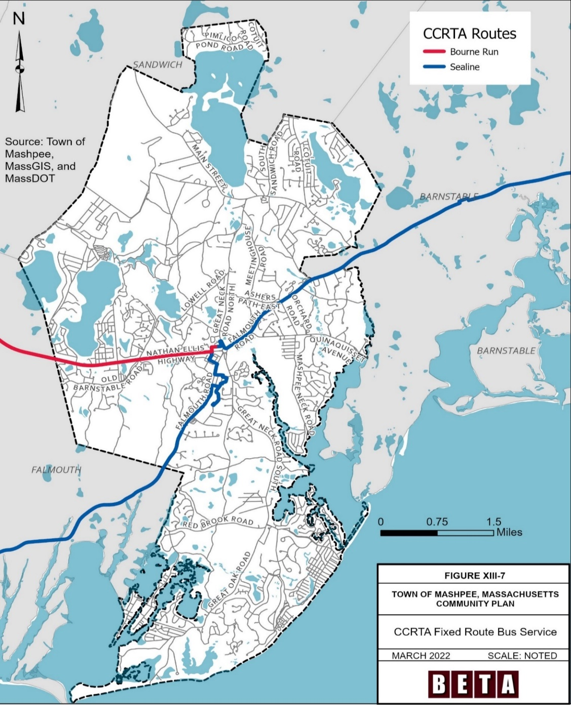
The CCRTA offers round trip service Monday through Thursday to Boston Area Hospitals. The service picks up in Wellfleet, Eastham, Orleans, Barnstable, Wellfleet, Harwich, and at the Sagamore commuter lot. The service can also pick up in Mashpee based on availability. CCRTA runs the service with shared, accessible vehicles to eight Boston hospital locations, including Massachusetts General Hospital, Tufts Medical Center, Boston Medical Center, Boston Children’s Hospital, Beth Israel, New England Baptist Hospital, Faulkner Hospital, and Carney Hospital. The service costs $30 round trip. CCRTA recommends riders make medical appointments at 11 AM when using the service. The service requires a reservation.

Figure 9-7. CCRTA Fixed Route Bus Service
Source: Town of Mashpee, 2022
School Buses
The Town provides buses for children to get to school. The Town owns the school buses and contracts out the bus service to a private operator. All students in Mashpee, regardless of how far they live from school, are eligible to take the school bus.

Roadways
Roadway Classification
Roadway Class | Miles | % of Miles
Interstate | 0 | 0%
Arterial | 23.8 | 10%
Collector | 9.6 | 4%
Local | 201.1 | 86%
TOTAL | 234.5 | 100%
Roadway classifications can be broken down into a hierarchy that ranges from interstates, providing high levels of vehicle mobility and low levels of vehicle access, to local roadways, providing low levels of vehicle mobility and high levels of access. Table 9-2 shows the total length of each classification of roadway in Mashpee and Figure 9-6 illustrates the roadway classification system in Mashpee.
Table 9-2. Classification of Roadways in Mashpee
Source: MassDOT Road Inventory, 2018
Interstates
Mashpee does not have an interstate highway located in Town or nearby.
Arterials
Arterial roadways provide the second-highest level of vehicle mobility and are not primarily intended to provide access to abutting properties. Mashpee contains approximately 24 miles of arterials making up 10 percent of its transportation network. Main Street (Route 130), Nathan Ellis Highway (Route 151), and Falmouth Road (Route 28) are principal arterials, while Great Neck Road, Quinaquisset Avenue, Cotuit Road, Red Brook Road, and Great Oak Road are minor arterials. The primary purpose of major arterials is to move heavy traffic efficiently and safely, while minor arterials typically move traffic between major arterials and provide moderate access to abutting properties.
- Route 130 (also known as Main Street) is a north-south major arterial running from close to 6A in Sandwich to Route 28 in Barnstable with a connection to Route 6. The route generally provides one lane in each direction and runs through the north side of Mashpee.
- Route 151 (also known as Nathan Ellis Highway) is a route running east-west from the Mashpee Rotary to Route 28 in Falmouth. The route generally provides one lane in each direction.
- Route 28 (also known as Falmouth Road) runs from Eastham to New Hampshire via Boston. On Cape Cod, Route 28 runs along the western and northern sides of the peninsula providing access to Harwich, Chatham, Falmouth, Yarmouth, Barnstable, Dennis, and Bourne.
Collector Roads
Collector roads move traffic from local streets to arterials. They provide moderate amounts of vehicle mobility and moderate vehicle access to adjacent properties. Mashpee contains approximately 10 miles of collector roadways, making up four percent of its roadway network, which is typical of Cape Cod towns. In Mashpee, major collector roadways include South Sandwich Road, Meetinghouse Road, Lowell Road, Old Barnstable Road, Mashpee Neck Road, Orchard Road, Pimlico Pond Road, and Asher’s Path East.
Local Roadways
Local roadways provide the highest level of vehicle access to adjacent properties with the lowest level of vehicle mobility. Approximately 86 percent of all roadways in Mashpee fall under this classification.
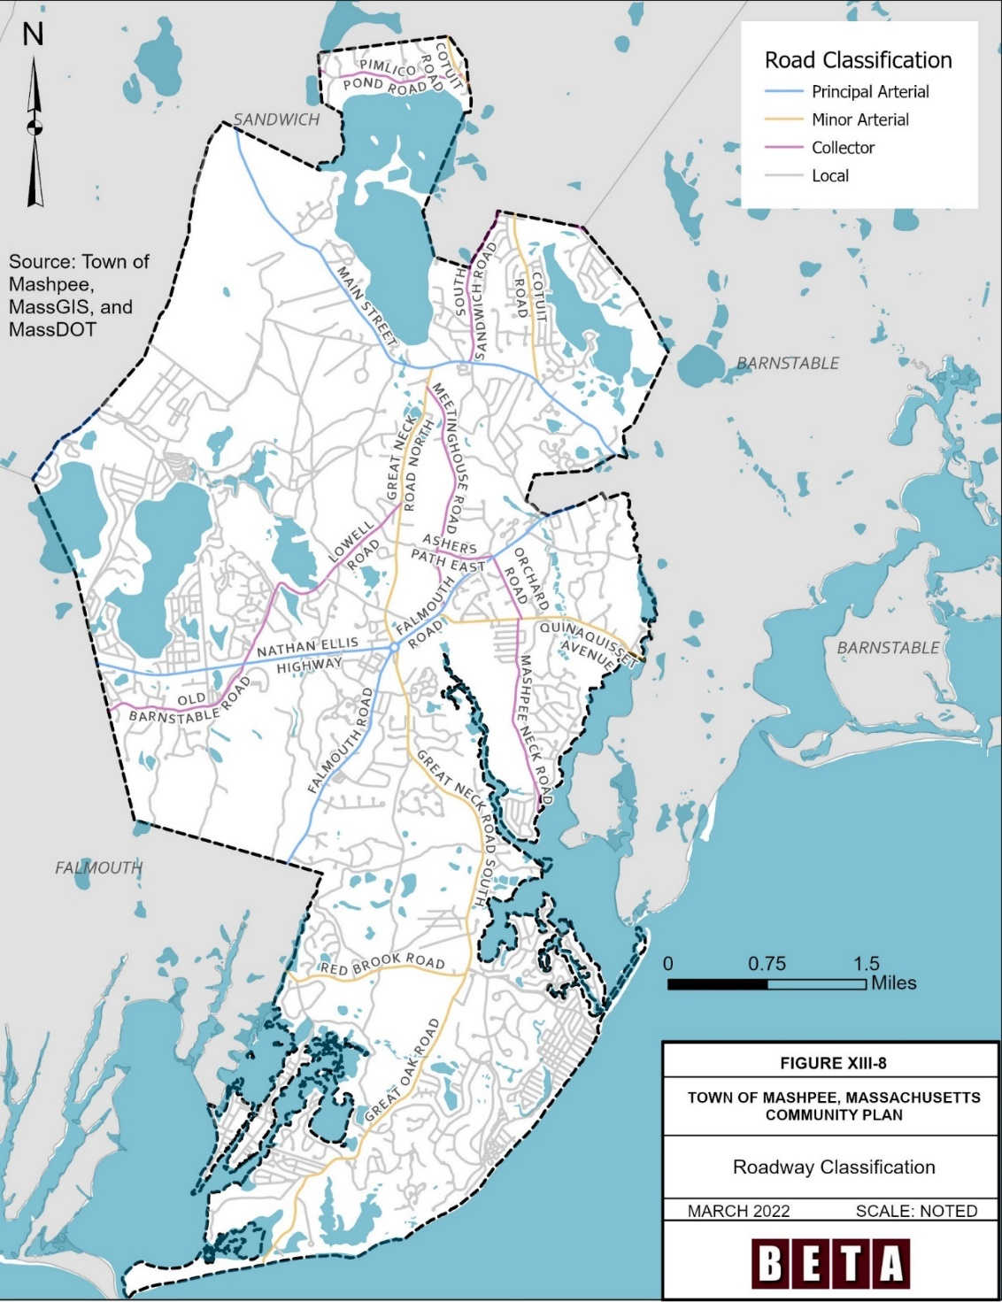
Figure 9-8. Roadway Classification
Source: Town of Mashpee, 2022
Roadway Jurisdiction and Tribal Roadways
Table 9-3 shows the roadway miles in Mashpee under Town, State, private, and Federal jurisdiction. Around half of Mashpee’s roadways are under Town jurisdiction. Falmouth Road, including the Mashpee rotary, is the only state-owned (MassDOT) road in Town. The US Air Force roadways are within the Otis Air Base. The high percentage of roads under private jurisdiction is due to the many subdivision complexes in Mashpee. Figure 11 shows roadways by jurisdiction in Mashpee.
Jurisdiction | Miles | % of Miles
Private | 111.5 | 48%
Town | 116.1 | 49%
State | 4.1 | 2%
US Air Force | 2.8 | 1%
TOTAL | 234.5 | 100%
Table 9-3. Jurisdiction of Mashpee Roadways
Source: MassDOT Road Inventory, 2018
Several state and Town-owned roads in Mashpee are also listed under the Indian Reservation Roadways program. Indian Reservation Roads (IRR) are public roads that are located within or provide access to an Indian reservation, Indian trust land, or restricted Indian land. In Mashpee, IRR roads include parts of Route 151, Route 28, Red Brook Road, Route 130, Great Neck Road, Quinaquisset Avenue, Sampson’s Mill Road, Meetinghouse Road, Cotuit Road, and Old Barnstable Road (Mashpee Wampanoag Tribe, 2013).
Traffic Volumes
Table 9-4 shows average daily traffic volumes (AADT) on Mashpee roadways collected between 2014-2021.
The data show that traffic volumes are heaviest on Route 151 (Nathan Ellis Highway) and Route 28 (Falmouth Road). Traffic volumes on Route 151 east of Old Barnstable Road grew seven percent from an average daily traffic volume (AADT) of 17,364 in 2016 to 18,618 in 2019. Volumes decreased significantly in 2021, down to 10,571, reflecting a decrease in travel during the COVID-19 pandemic.
According to Town staff, traffic in Mashpee varies greatly by time of day and season. For example, Route 151 and Old Barnstable Road are both busy around school pick-up and drop-off times, particularly during the pandemic when fewer students chose to take the bus. Mashpee also has more traffic in the summer months than the winter months, as visitors come to enjoy Mashpee’s beaches and natural resources. In the summer, week-long rentals change over on Saturday generating delays and long queues in Town. Figure 9-9 shows average daily traffic volumes.
Location | 2014 | 2015 | 2016 | 2017 | 2018 | 2019 | 2020 | 2021
Great Neck Road south of Route 130 |  | 16,079 |  |  | 15,207
Great Neck Road south of Donna’s Lane | 9,270 | 11,186 |  |  |  |  |  | 9,011
Great Neck Road north of Mashpee Rotary |  |  | 10,448 |  |  | 11,435
Nathan Ellis Highway (Route 151) west of Market Street |  |  |  |  | 13,697
Old Barnstable Road north of Nathan Ellis Highway (Route 151) |  |  | 7,770 |  |  | 8,615
Nathan Ellis Highway (Route 151) west of Mashpee Rotary | 13,719 | 13,602 |  | 12,813 |  | 13,625
Nathan Ellis Highway (Route 151) west of Old Barnstable Road | 21,516 |  |  |  |  |  |  | 11,825
Nathan Ellis Highway (Route 151) east of Old Barnstable Road |  |  | 17,364 | 16,690 | 17,679 | 18,618 |  | 10,571
Falmouth Road (Route 28) east of Donna’s Lane | 17,727
Falmouth Road (Route 28) at Orchard Rd & Asher’s Path |  |  | 19,361
Falmouth Road (Route 28) east of Industrial Way |  |  |  |  | 14,273
Falmouth Road (Route 28) west of Mashpee Rotary |  |  |  | 15,205
Cotuit Road at Sand/Mash TL (N end) | 6,893 |  |  | 7,303 | 7,103
Main Street west of South Sandwich Road | 10,958 |  |  |  |  | 10,978
Table 9-4. Average Daily Traffic Volumes at Highest Volume Locations
Source: MassDOT Transportation Data Management System

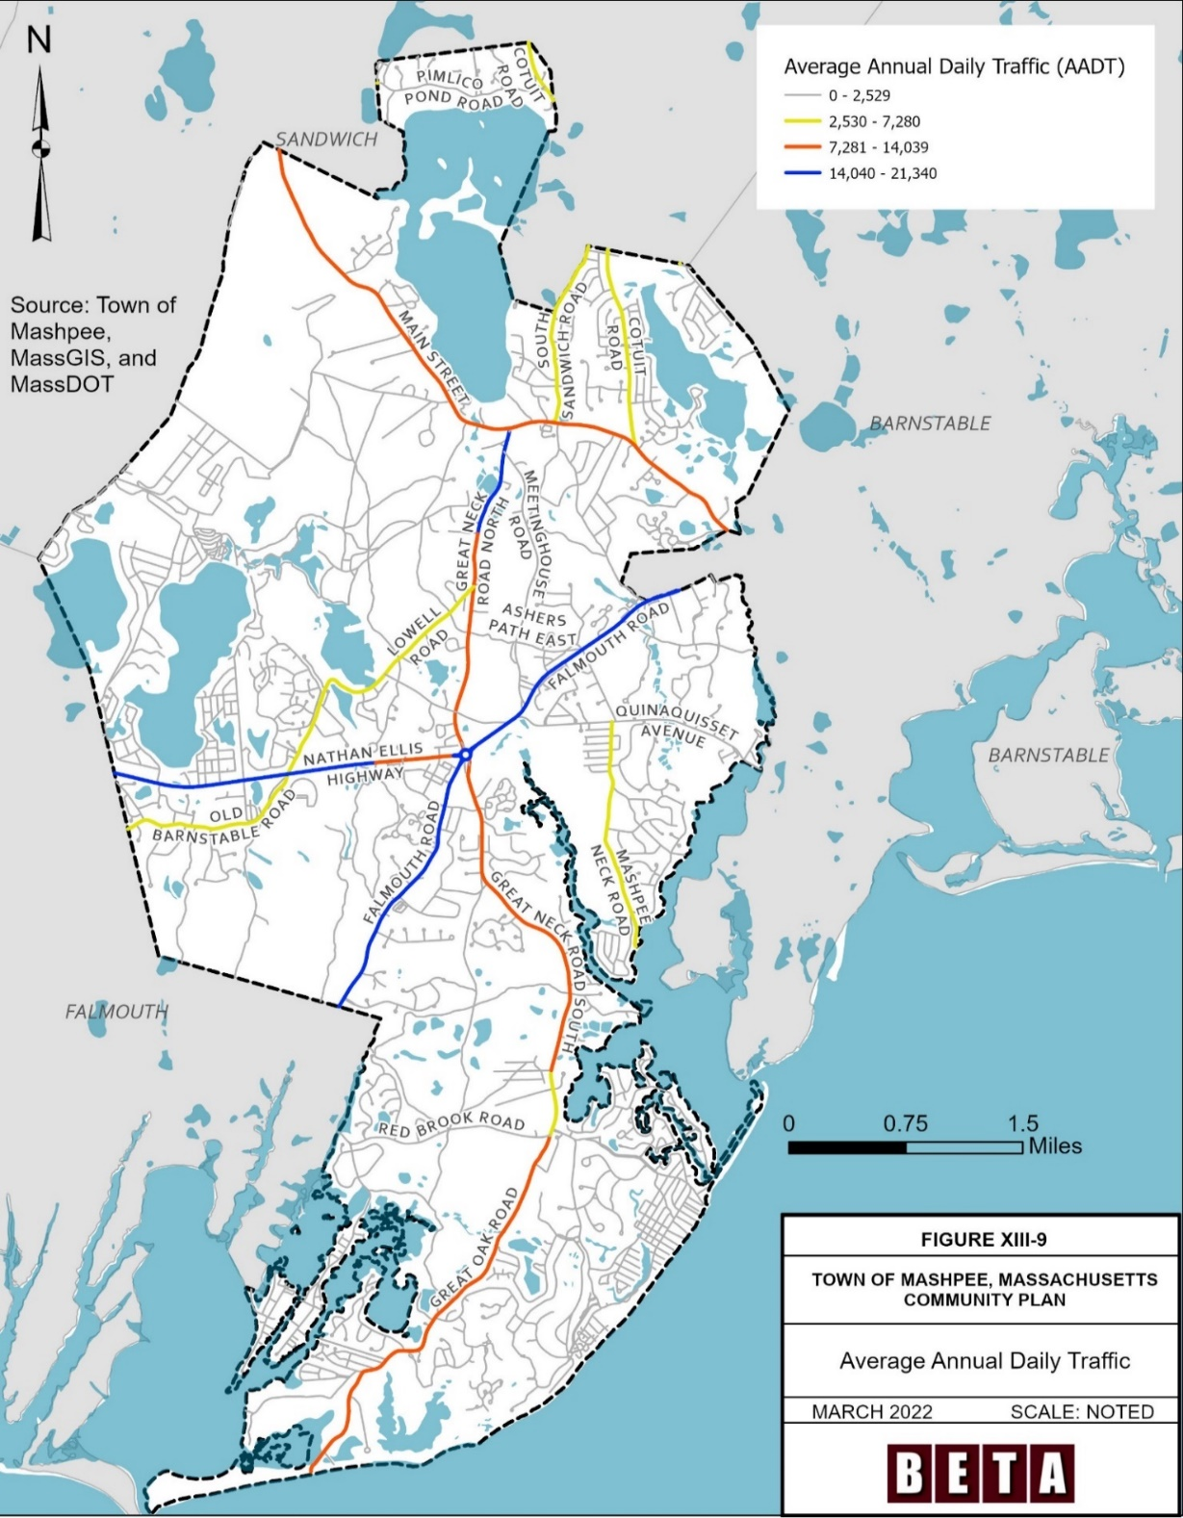
Figure 9-9. Average Annual Daily Traffic
Source: Town of Mashpee, 2022
Roadway Safety
Crash data available from Massachusetts Department of Transportation (MassDOT) indicate that 3,265 crashes, or an average of approximately 327 crashes per year, have occurred in Mashpee from the years 2012 to 2021. As shown in Figure 9-10, the total number of crashes each year has fluctuated since 2012, with a low of 245 in 2020 and a high of 396 in 2013. From 2013 to 2021, the total number of crashes has trended downward, with a record low in 2020 (as a result of fewer vehicle trips being made during the Covid-19 pandemic). The total number of crashes in 2021 (297) was comparable to the number in 2019 (292). However, while total crashes have decreased over time, the total number of crashes resulting in injury has remained steady. In 2021, 12 crashes resulted in serious injury, compared to an average of five crashes in the past ten years.

Figure 9-10. Total Crashes by Severity

Source: MassDOT Interactive Mapping Portal for Analysis and Crash Testing
Crash Type
Of the 3,265 crashes from 2012 to 2021, 34 crashes involved pedestrians, and 15 crashes involving bicyclists. During that same time frame, 2,286 crashes resulted in no injuries, 426 resulted in possible injury, 370 resulted in minor injury, 50 resulted in serious injury, and six crashes resulted in fatal injury. Of the 50 crashes resulting in a serious injury or death, 15 involved an older driver, 9 involved a younger driver, 8 involved a pedestrian, 3 involved a bicyclist, and 3 involved a motorcyclist.
Out of the six fatal crashes, three crashes involved a person walking. One occurred at the Quinaquisset Avenue and Orchard Road intersection involving a person under 15 years old, one occurred at the intersection of Falmouth Road and Bowdoin Road and involved a person between age 55 and 64, and one occurred at the intersection of Falmouth Road and Orchard Road and involved a 91-year-old woman crossing the street from a CCRTA bus. All three fatal crashes occurred at night and two were on unlit roadways. MassDOT identified Route 151 and Market Street as a high pedestrian crash cluster with six total crashes, five resulting in injury or death, between 2010 and 2019. Generally, crashes involving people walking occur near the center and east of Town.
Highway Safety Improvement Program
MassDOT maintains a database of top crash locations in the state. This database includes locations identified under the Highway Safety Improvement Program (HSIP) in addition to a list of the top 200 crash locations in the state.
For the years of 2017-2019, Figure 9-11 shows the intersections in Mashpee identified as HSIP clusters and high crash locations.
Intersection | Total Crashes Between 2017 and 2019
Nathan Ellis Highway (Route 151) and Old Barnstable Road | 26
Great Neck Road North and Main Street (Route 130) | 18
Nathan Ellis Highway (Route 151) and Job’s Fishing Road | 15
Old Barnstable Road and Great Neck Road North | 14
Algonquin Avenue and Nathan Ellis Highway (Route 151) | 11
Great Neck Road North and Meetinghouse Road | 10
Falmouth Road (Route 28) and Asher’s Path East | 9
Table 9-5. HSIP Locations
Source: MassDOT Interactive Mapping for HSIP Clusters, 2020

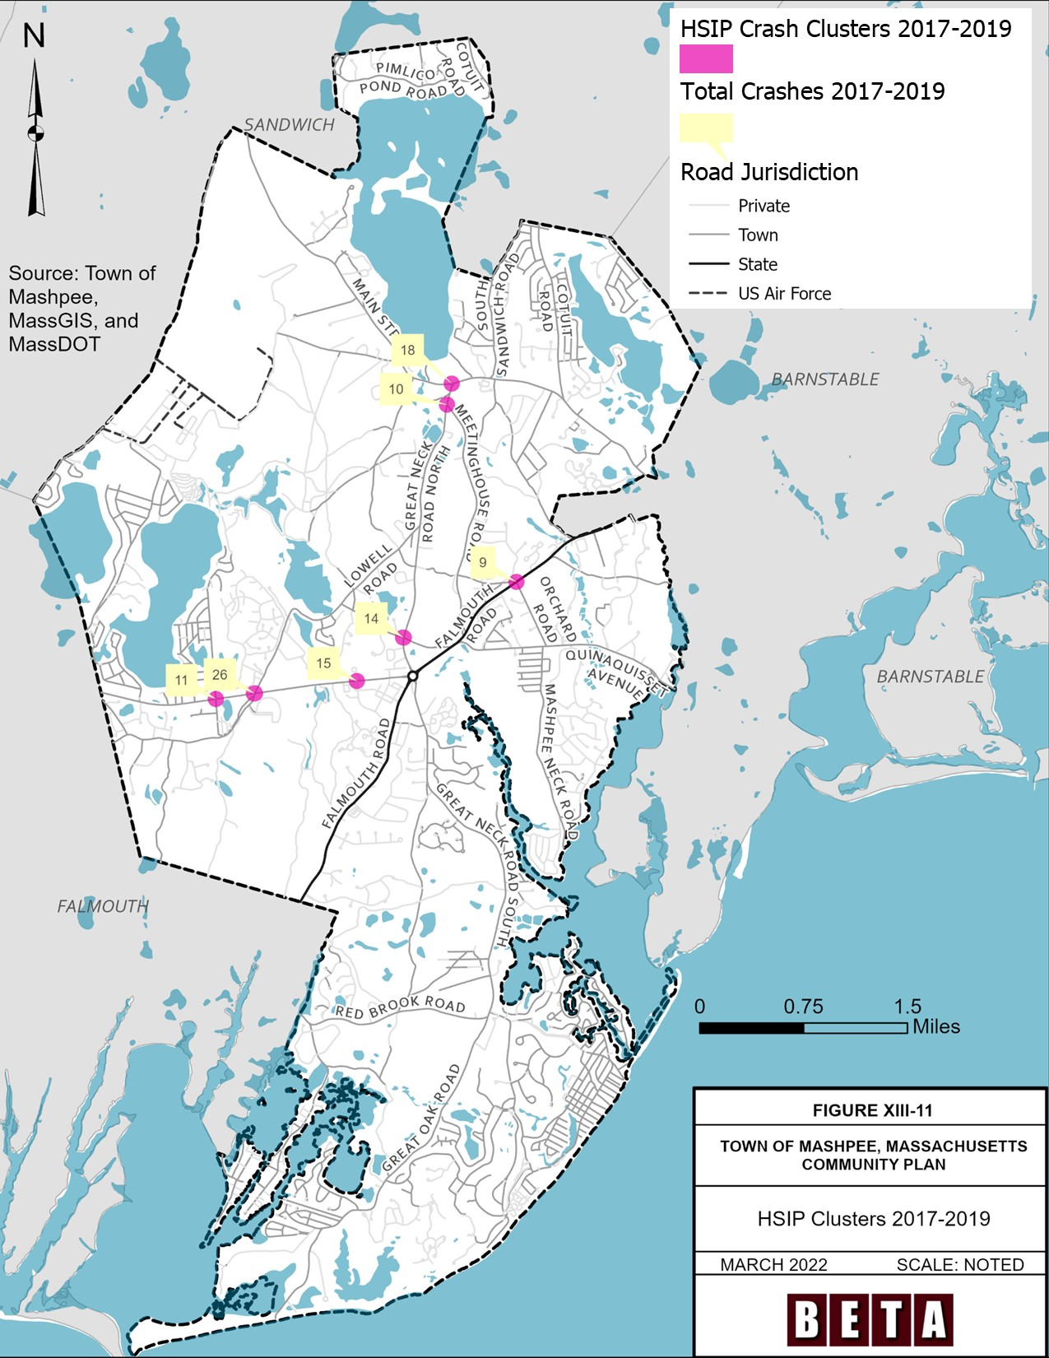
Figure 9-11. HSIP Clusters, 2017-2019
Source: Town of Mashpee, 2022
Other Safety Concerns
The Mashpee Police Department and Department of Public Works identified high vehicle speeds as a safety challenge on Route 28 between Orchard Road and Old Barnstable Road, Route 151 by Old Brickyard Road, Orchard Road, and South Sandwich Road, based on observation. Currently, the Town does not have any speed feedback signs or a speed trailer.
Town staff also identified several wide intersections that have visibility issues for turning vehicles. These include the intersections of South Sandwich Road and Route 130, Meetinghouse Road and Great Neck Road North, Old Barnstable Road and Great Neck Road North, Great Neck Road South and Great Oak Road, Meetinghouse Road and Route 28, Quinaquisset and Route 28, Sampson’s Mill Road and Route 28, and Monomoscoy Road and Red Brook Road.

Pedestrian and Bicycle Accommodations
Mashpee has around 12 miles of dedicated paths for people walking or biking, in the form of either a sidewalk or a shared-use path. These sidewalks and shared-use paths are on around 10 percent of Town-owned roads and on around 30 percent of Mashpee’s arterial and collector roadways. The paths extend primarily along the arterial and collector roadways close to the center of Town, and throughout most of the Mashpee Commons commercial complex.
In addition to the shared-use paths and sidewalks on Mashpee’s roadways, the Town has some shared-use pedestrian connections that help fill the gaps along roads. For example, there is a shared-use path connecting Mashpee Police Department, Kenneth C. Coombs Elementary School, the Stop & Shop Complex, and the 99 Restaurant in the center of Town. This connection allows people walking or biking to bypass the northwest side of the rotary.
A major gap in the path network is located at the Mashpee Rotary, where paths coming from Great Neck Road North and Great Neck Road South, Route 151 (Nathan Ellis Highway) and Route 28 (Falmouth Road) abruptly end at the rotary. In general, the collector and arterial roadways on the east side of the Mashpee rotary do not have dedicated paths, while the western side of Town does. Many private roadways do not have sidewalks because, while the subdivision regulations in Mashpee require developers to put a sidewalk on at least one side of the roadway, this requirement is frequently waived because roads in subdivisions frequently dead end. Figure 9-12 shows the sidewalks and shared-use paths along roadways in Mashpee.
In Mashpee, people on bikes are permitted to ride on the Town’s sidewalks and paths, but there are a few on-street bike lanes in the form of a painted four- to five-foot-wide shoulder on Great Neck Road South, Red Brook Road, and Great Oak Road. Mashpee offers bike parking at locations around Town, including in Mashpee Center, John’s Pond, and at the recreational fields off of Main Street. The Town of Mashpee received funding from the Cape Cod Commission for bike racks.
The Town has several off-road trails for both biking and walking within the following recreational areas:
- Besse’s Bog
- Child’s River
- Jehu Pond
- John’s Pond
- Noisy Hole
- Santuit Pond
- Pickerel Cove
- Mashpee River Woodlands
- Pine Barrens
- Quashnet River Woodlands
- Lowell Holly Reservation
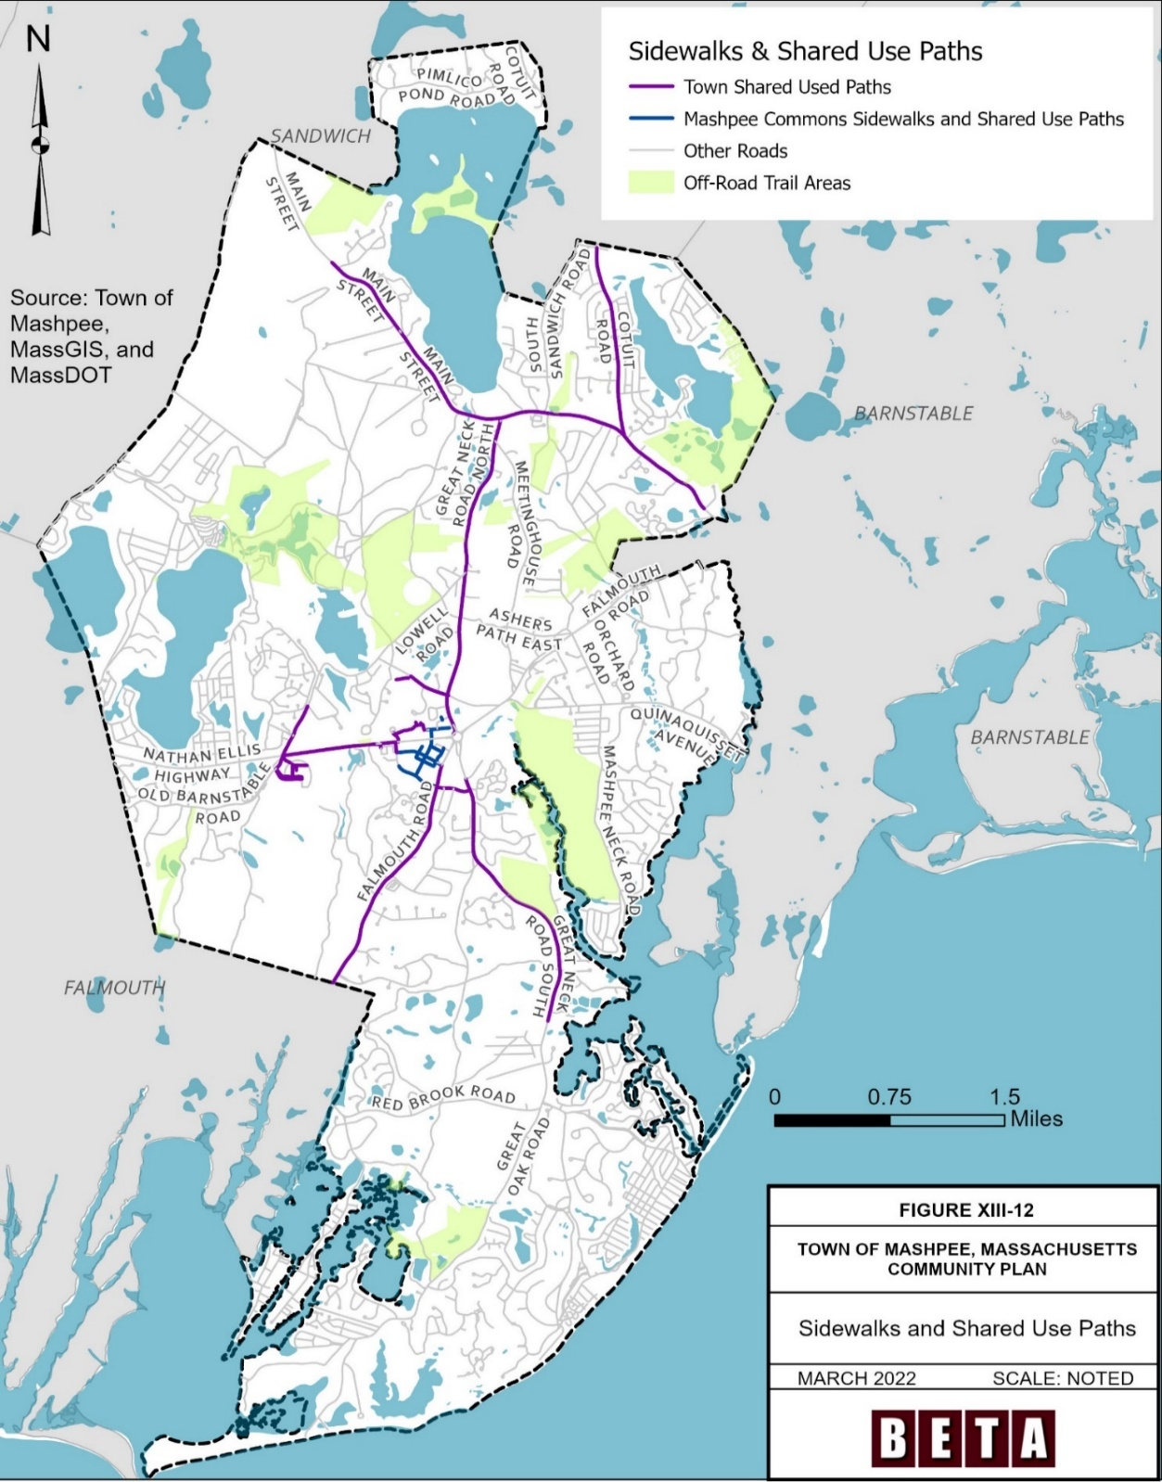
- Mashpee’s beaches, extending more than five miles along the waterfront
Figure 9-12. Sidewalks and Shared Use Paths
Source: Town of Mashpee, 2022
Several recent and proposed projects in Mashpee are focused on expanding and improving the network of trails, paths, and sidewalks. Some of the proposed projects in Mashpee are the result of the Town’s Complete Streets Prioritization Plan. The Massachusetts Complete Streets Funding program provides technical assistance and construction funding to eligible municipalities who pass a Complete Streets Policy and develop a Prioritization Plan. The program funds projects making the public right of way accessible to people of all ages, abilities, and modes of travel, including walking, biking, driving, and using public transportation. The Town of Mashpee passed a Complete Streets Policy in 2018 and developed a Prioritization Plan in 2020. Mashpee’s Complete Streets program has 22 projects in the prioritization plan, with the highest-ranked improvements on Route 151, South Sandwich Road, Orchard Road, and Old Barnstable Road (MassDOT, 2020). The projects proposed include new sidewalks, speed feedback signs, rapid rectangular flashing beacons, multiuse paths, traffic calming, intersection improvements, and bike lanes.
Further information on recent and planned improvements for walking and biking is in the Recent and Planned Projects section of this chapter.

Parking
The Town of Mashpee owns three beach parking lots at South Cape Beach, Attaquin Park, and John’s Pond. To use these parking lots in the summer season, Mashpee residents and residential property owners must purchase a beach sticker for $30 and Mashpee visitors must purchase a weekly pass for $50.
- South Cape Beach Town parking lot has around 120 spaces, including 6 accessible spaces
- Attaquin Park Town parking lot has around 70 spaces, including 3 accessible spaces
- John’s Pond Town parking lot has around 75 spaces, including 4 accessible spaces
Other Town surface parking is available at the Mashpee Senior Center, Fire Department and Police Department complex, Mashpee Recreation Department, Mashpee Town Hall, Mashpee Department of Public Works, Mashpee Public Library, Mashpee Community Park, Quashnet Elementary School, and Mashpee Middle-High School. The Town also provides parking lots at some of the Town’s conservation areas for people accessing trails, and at some of Mashpee’s boat ramps. During the summer, parking at Town-owned boat ramps is restricted to Mashpee vehicles with a permit.
The State owns a parking lot at South Cape Beach with discounted prices for Massachusetts residents.
Mashpee Commons, Mashpee’s commercial hub, has a mix of on-street parking and an abundance of surface parking lot spaces. Most residential and commercial developments in Town offer surface parking lots and most single-family homes have driveways.
Mashpee Commons has a publicly available electric vehicle charging station, where people with Tesla vehicles can pay to recharge. The Town also has electric vehicle charging stations at the Town Hall dedicated to Town-owned electric vehicles.

Airports
The Otis Air National Guard Base is located northwest of Mashpee. The Coast Guard uses this airbase, but no commercial or private flights are allowed. The closest airport with commercial flights is in Barnstable.

Marinas and Boat Ramps
Mashpee has three private marinas.
- Little River Boat Yard is a private marina located on Seconsett Island with access to Waquoit Bay and Vineyard Sound. They offer both slips and rack boat storage, along with other maintenance and fueling.
- New Seabury Marina is a private marina located with the New Seabury housing community. The marina offers fuel, docking, and boating supplies. The slips are available seasonally or on a transient basis.
- Mashpee Neck Marina is a private marina with 154 slips located on Popponesset Bay.
In addition to the marinas in Mashpee, the State owns two boat ramps, Mashpee/Wakeby State Boat Ramp and John’s Pond State Boat Ramp, and the Town of Mashpee owns Great River Boat Ramp, Edward A. Baker Boat ramp at Pirate’s Cove, Santuit Pond Boat Ramp, and Ockway Bay Boat Ramp.

Maintenance of Infrastructure
Pavement Management Program
The Town of Mashpee implements a pavement management program to monitor the conditions of roadways and prioritize their repair. The GIS-based program collects and evaluates data about the condition of roadways in order to determine a Pavement Condition Index (PCI) and schedule of maintenance. The PCI is a pavement scoring system based on 100 points, with 100 being the best score. The Pavement Condition Index for the Town of Mashpee is 78.8 for arterial roads and 86.9 for residential roads (Stantec 2020). Figures 9-13 and 9-14 shows the condition of roadways in Mashpee.
Bridges
According to the most recently available data in MassDOT’s database, five bridges are located in Mashpee. Of the five bridges, MassDOT found one bridge was structurally deficient (Route 28 Falmouth Road over the Mashpee River). Figure 9-15 shows the condition of bridges in Mashpee.

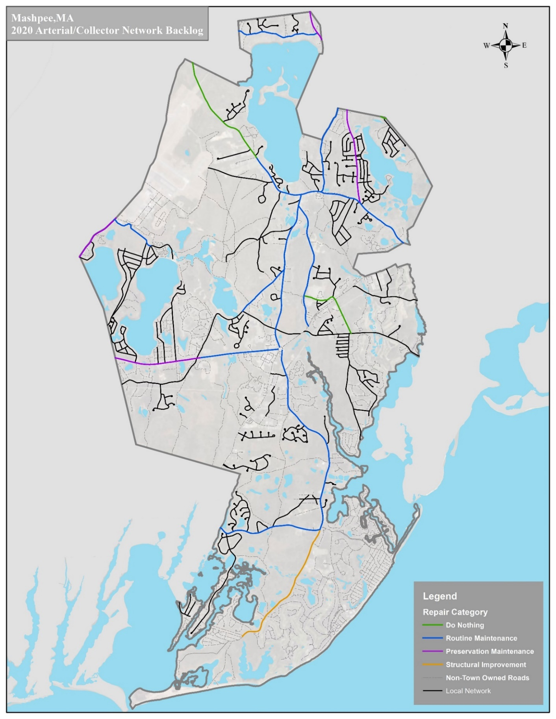
Figure 9-13. Pavement Management Summary 2020 for Arterial/Collector Network
Source: Stantec, 2020
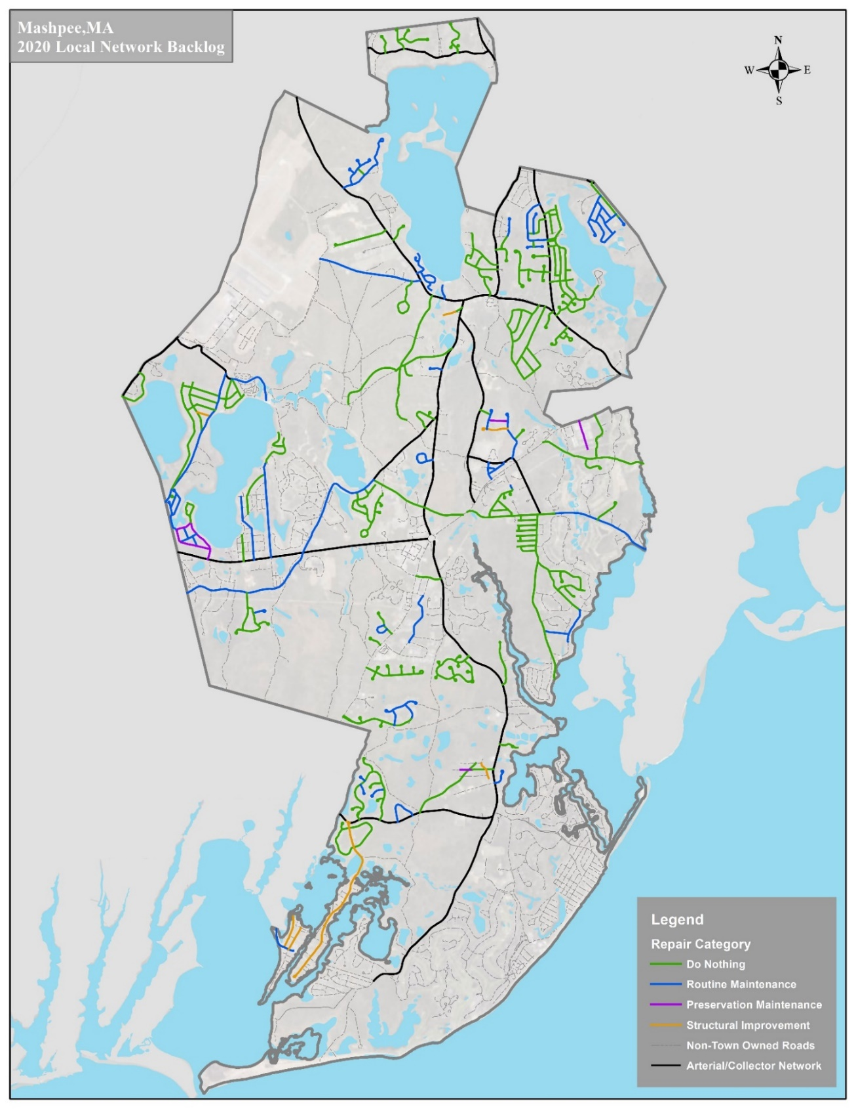
Figure 9-14. Pavement Management Summary 2020 for Local Network
Source: Stantec, 2020
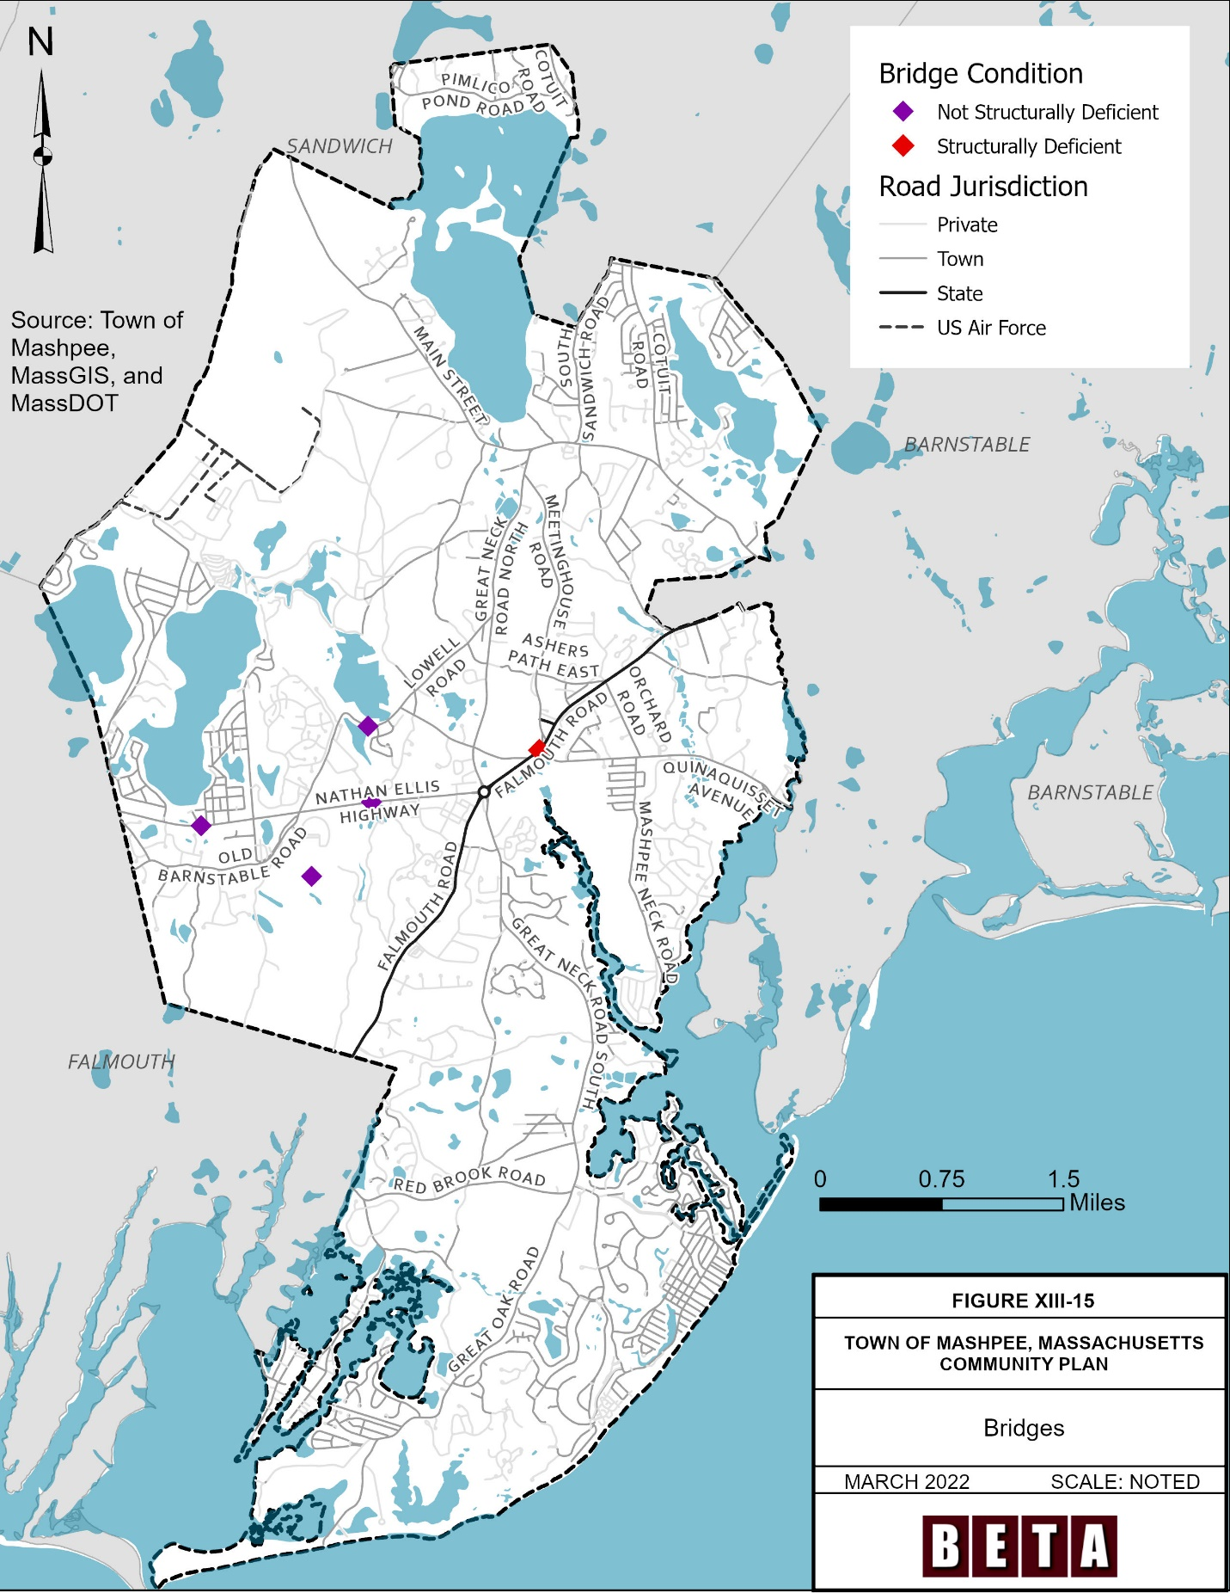
Figure 9-15. Bridges
Source: Stantec, 2020

Challenges & Opportunities
The following transportation-related issues were identified:
- Residents and Town staff have identified speeding as being an issue in Town, particularly along Route 28 and Route 151.
- Only 30 percent of arterial and collector roadways in Mashpee have sidewalks or shared-use paths.
- Route 28 east of the Mashpee Rotary lacks a sidewalk or shared-use path and crossings for people accessing the Sealine CCRTA route.
- Three people were killed while walking in Mashpee in the past 10 years, all three deaths occurring at night, and two on unlit roadways.
- The Town is required to work with private developers, the Mashpee Wampanoag Tribe, and the State to develop and improve the roadway network. Only around half of the roads in Mashpee are under the jurisdiction of the Town, and some roads under Town jurisdiction are Indian Reservation Roads.
- Adding high visibility crossings and bus amenities is a challenge along the CCRTA routes. Generally, the CCRTA buses running in Town do not have designated bus stops, as the buses can be flagged.
- While crashes have been declining overall over the past 10 years, crashes resulting in injury have remained steady, and serious injury crashes have increased in the past three years.
- One bridge in Mashpee (Falmouth Road over the Mashpee River) was found structurally deficient by MassDOT.
- The Mashpee Rotary lacks pedestrian or bike accommodation and has a high number of minor vehicle crashes.
- When new roads get built in Mashpee, DPW does not receive an increase in maintenance funds.
- Traffic in Mashpee is highly variable by time of day and season, including school drop-off times and summer rental changeovers.
- The majority of Mashpee households commute by driving alone, demonstrating a general car dependency; however, the dependence on driving alone varies geographically in. In the northwest section of Town, a lower percentage of residents drive alone to commute, and a higher percentage do not have a vehicle compared with other parts of Town.
- High crash locations in Mashpee include Great Neck Road North and Old Barnstable Road, Great Neck Road North and Meetinghouse Road, Great Neck Road North and Route 130, the Mashpee Rotary, Route 151 and Old Barnstable Road, Route 151 and Job’s Fishing Road, Route 151 and Algonquin Avenue, and Route 28 and Asher’s Path East.
- Truck volumes on Lowell Road were identified as an issue.

Opportunities
The following transportation-related opportunities were identified:
- The Town has adopted a Complete Streets Policy and created Project Prioritization Plan, so is eligible to apply for up to $400,000 of infrastructure funding from the MassDOT.
- The Mashpee Rotary Study offered recommendations and support for improving bicycle and pedestrian connectivity and safety for all road users through the Mashpee Rotary.
- Several intersections in Mashpee would benefit from tighter curb radii and intersection realignment to improve visibility, lower vehicle speeds for turning vehicles and reduce pedestrian crossing distances. These include South Sandwich Road at Route 130, Meetinghouse Road at Great Neck Road, Old Barnstable Road at Great Neck Road North, Meetinghouse Road at Route 28, Quinaquisset at Route 28, and Sampson’s Mill Road at Route 28.
- Mashpee has “hidden” pedestrian connections that could be enhanced by wayfinding signage and improved connectivity to other pedestrian infrastructure.
- The Town has expressed interest in a speed trailer to better enforce speeding on critical roadways in Town.
- Mashpee does not currently participate in MassDOT’s Safe Routes to Schools program. The program can provide education and encourage programs and funding to improve walking and biking facilities around elementary and middle schools.
- The Town has expressed interest in a bicycle and pedestrian plan to prioritize improvements in Town for people walking and biking.
- MassDOT has identified seven Highway Safety Improvement Program crash clusters in Mashpee eligible for a road safety audit. Road safety audits have already been conducted at four of these crash clusters. The intersections of Great Neck Road North and Meetinghouse Road, Route 28 and Asher’s Path East, and Great Neck Road and Route 130 are eligible for Road Safety Audits.
- The Town could benefit from increasing pedestrian scale lighting and high visibility crossings at areas where people walk across the street, for example, at higher ridership bus stops.
- The Town could benefit from adding a bus shelter at Mashpee Commons CCRTA stop.
- A sidewalk plow is needed to maintain accessibility in winter.
- The Town of Mashpee does not currently have any speed feedback signs, but there is an opportunity to apply for these using MassDOT Shared Streets and Spaces grant funding.
- The Town approved a roundabout redesign at Route 130 and Great Neck Road North and is looking for funding opportunities.
- The Town of Mashpee has several public transportation options serving the community including two fixed-route buses, paratransit, Boston Hospital service, and school buses for all children. There is just one bus shelter in Town located at the Community Health Center serving the Sealine route. There is an opportunity to add bus amenities at other locations in Town.
- There are existing studies on the Route 28 Corridor by both the Cape Cod Commission and MassDOT that could be referenced to improve this corridor.
- The Cape Cod Commission is examining where to put electric vehicle (EV) charging stations across Cape Cod, including in the Town of Mashpee.
- The Cape Cod Commission is beginning an inventory of side path crossings in Mashpee and other Cape towns starting in the summer of 2022.

Current Measures
The following transportation-related projects are currently planned or under construction in Mashpee:
- Mashpee, Route 151 Corridor Improvements (Phase 1) (2021-2022): This Transportation Improvement Program (TIP) funded project will include intersection improvements, new drainage, pavement markings, signage, and traffic signal upgrades at the intersections of Job’s Fishing Road, Old Barnstable Road, and Market Street. The project will improve pedestrian and bicycle accommodation both along the corridor and at key intersections. The Cape Cod Commission expects the improvement in active transportation options will lower greenhouse gas emissions on the Cape by approximately 8,000 kilograms per year. The $5 million project is mostly funded using federal grants. This project received the highest prioritization score in the 2022-2026 TIP out of the 31 considered projects. Work has already begun on the project and is expected to be completed in 2025 (Cape Cod Commission 2021).
- Mashpee, Route 151 Corridor Improvements (Phase 2) (2026): This TIP project will include installation of new turn lanes, a small portion of raised median, new drainage, pavement markings, a shared-use path, and a sidewalk from the Falmouth Town Line to just west of Old Barnstable Road. This $8 million project is mostly funded using federal grants. This project received the fifth-highest prioritization score in the 2022-2026 TIP out of the 31 considered projects. The project is expected to be completed in 2026-2027.
- Great Neck Road and Route 130 Roundabout: The Town recently approved this project in early 2021 and the project is in the conceptual design stage. The goal of the project is to make the intersection safer. The final design and construction are not yet funded.
- Old Barnstable Road Improvements: The Mashpee Wampanoag Tribe received a $300,000 grant to redesign Old Barnstable Road from Route 151 to the Falmouth Town Line. The goal of the project is to add sidewalk and drainage improvements, in response to a death of a young adult walking on this road.
- Mashpee Rotary Retrofit: The State plans to retrofit the rotary, as recommended by the Mashpee Rotary Study (see below) and add pedestrian and bicycle accommodation. This project is not yet funded for construction. As of early 2022, MassDOT has hired an engineer to begin design on the rotary retrofit.
- Prioritized Complete Streets Projects: The priorities from the Complete Street Prioritization Plan include improvements to bicycle and pedestrian accommodation across Town including on Route 151, South Sandwich Road, Orchard Road, and Old Barnstable Road. The projects are not yet funded.
- Speed Feedback Signs on South Sandwich Road and Orchard Road: The Town applied for Shared Streets & Spaces funding from MassDOT in Spring 2022 to add speed feedback signs along South Sandwich Road and Orchard Road, to reduce speeds and improve safety. The Cape Cod Commission conducted a speed survey for both roads to apply for this funding.
The following transportation-related projects were recently completed in Mashpee:
- Mashpee Rotary Study: Completed in August of 2019, this study was funded by MassDOT and the Federal Highway Administration Unified Planning Working Program and conducted by the Cape Cod Commission in Partnership with the Town of Mashpee. The study offered short-, mid-and long-term recommendations. The highest priority recommendations were a shared-use path around the rotary, rotary retrofit improvements, Route 28 directional signage on Donna’s Lane for retail traffic, and multi-modal accommodations, including a shared-use path, on Route 28 between Mashpee Rotary and Quinaquisset Avenue. Some of the short-term signage improvements have been completed. The next steps include securing funding for the remaining short-term improvements through Town, beginning the design process, and identifying state funds for the construction of the long-term improvements.
- Road Safety Audits:
  - Mashpee Rotary (2019)
  - Nathan Ellis Highway (Route 151) at Job’s Fishing Road, Algonquin Ave and Ninigret Ave (2018)
  - Nathan Ellis Highway (Route 151) at Old Barnstable Road Intersection (2014)
  - Great Neck Road North/Old Barnstable Road (2009)
  - Route 130 Lane Departure Road Safety Audit (2007
- Route 28 Eastern Mashpee Corridor Study: Completed in January 2018 and funded by the Unified Planning Work Program, this report examined existing conditions, recommended short-term, mid-term, and long-term improvements, and alternatives development for the section of Route 28 from Route 130 to Orchard Road. This section of roadway was prioritized due to safety and congestion issues. This study recommended improvements included a speed study, traffic signal improvements, new turn lanes, visibility improvements, sidewalks, and improved crosswalks.
- Intersection Realignment at Cotuit Road: The Town recently completed an intersection realignment at Cotuit Road and Route 130 to improve sightlines.

Goals & Policies
Goals
- Maintain and enhance a cost-effective, efficient, safe, and accessible multi-modal transportation system that is sensitive to and respectful of the Town’s small-town character.
- Support efforts to enhance and increase alternative modes of transportation such as ride shares, bicycling, and public transportation with an eye towards reductions in greenhouse gasses and air pollution.
- Minimize and mitigate impacts of transportation issues such as congestion as the Town considers its growth pattern to ensure maintenance of Town’s quality of life, historic and natural resources, and small Town character
- Minimize financial impacts of new road construction on the Town’s budget.
- Ensure Mashpee’s stormwater management systems are utilizing best management practices to maximize the amount of stormwater treatment prior to recharging into groundwater.
- Minimize the impact of parking facilities on the Town’s visual character.
Policies
- Implement road design and maintenance standards and procedures that promote, protect, and encourage exiting patterns of development and neighborhood character in residential zoning districts.
- Maintain a formal program for road maintenance, new road construction, and accompanying drainage infrastructure that is economically responsible and implementable.
- Promote cooperative state/local efforts in transportation planning, ensuring that the Town’s qualities are maintained throughout any transportation planning and construction projects.
- Encourage alternative modes of transportation and increase opportunities in Town for access to biking, walking, and carpooling.
- Enhance connectivity between residential neighborhoods, as well as between commercial centers, and between neighborhoods, commercial center and municipal centers.

